Magnetic Resonance Imaging (MRI)

Definition: Non-invasive imaging technique using magnetic fields and radio waves to visualize internal body structures.

Chemistry Principles: Relies on the alignment and resonance of hydrogen nuclei (protons) in water molecules under a strong magnetic field.

Medical: Enables early diagnosis of tumors, neurological disorders, and musculoskeletal injuries.

Economic: Reduces costs associated with invasive surgeries.

Social: Improves patient quality of life through painless diagnostics.

Educational: Demonstrates principles of quantum mechanics and nuclear magnetic resonance (NMR) in classrooms.

Safety: Requires shielding from metallic objects and rigorous equipment maintenance to prevent accidents.

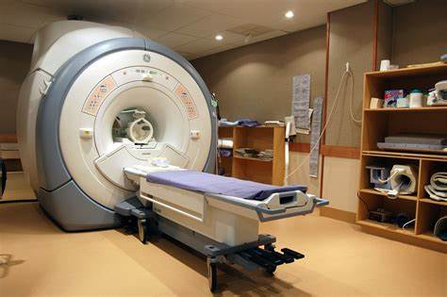

2. Infrared Spectroscopy

Definition: Analyzes molecular vibrations using infrared light absorption to identify chemical compounds.

Chemistry Principles: Molecules absorb specific IR wavelengths corresponding to bond vibrations (e.g., stretching, bending).

Applications:

Criminal Investigations: Identifies unknown substances (e.g., drugs, explosives) in forensic labs.

Education: Teaches students about functional groups and molecular structure.

Economic: Saves time and resources in forensic analysis.

Environmental: Detects pollutants in air/water samples.

Safety: Requires proper handling of hazardous samples and calibration of instruments.

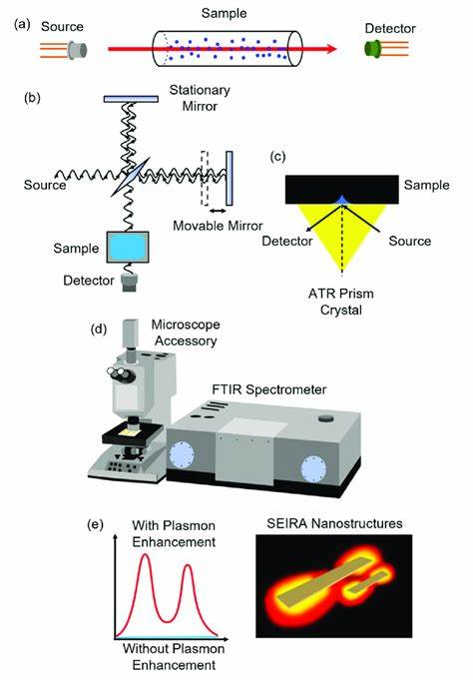

3. X-ray Crystallography

Definition: Determines atomic/molecular structures by analyzing X-ray diffraction patterns in crystals.

Chemistry Principles: X-rays scatter off electron clouds, revealing 3D atomic arrangements.

Medical: Critical for drug design (e.g., HIV protease inhibitors).

Economic: Drives innovation in materials science (e.g., superconductors).

Educational: Illustrates crystallography in chemistry curricula.

Safety: Requires lead shielding and protocols to minimize radiation exposure.

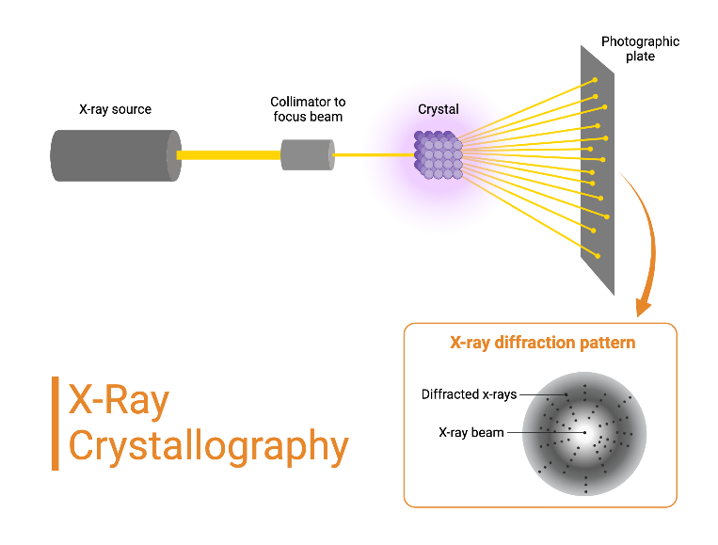

4. Nuclear Energy

Definition: Energy generated from nuclear fission (splitting uranium/plutonium nuclei).

Chemistry Principles: Chain reactions release energy via mass-to-energy conversion (E=MC^2)

Environmental: Low carbon emissions compared to fossil fuels.

Economic: Provides high energy output with minimal fuel.

Social: Powers cities and industries reliably.

Safety: Strict waste management (e.g., Canadian CANDU reactors use natural uranium and produce less long-lived waste).

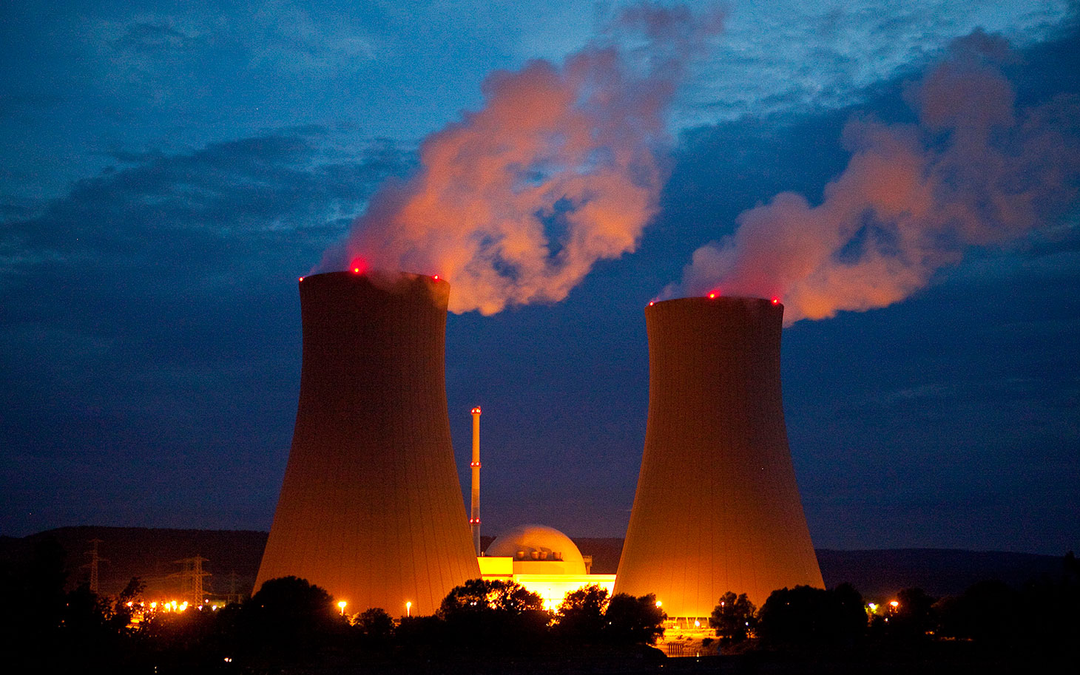

1. Medical Applications of Spectroscopy

Techniques: UV-Vis, fluorescence, and Raman spectroscopy.

Chemistry Principles: Light absorption/emission by electrons or molecular vibrations.

Medical: Monitors blood glucose (diabetes), detects cancers via fluorescence markers.

Economic: Reduces healthcare costs through rapid diagnostics.

Safety: Laser safety protocols in Raman spectroscopy.

6. Mass Spectrometry

Definition: Identifies molecules by ionizing them and measuring mass-to-charge ratios.

Chemistry Principles: Ionization (e.g., electron impact) and magnetic/electric field separation.

Medical: Detects metabolic disorders via newborn screening.

Environmental: Analyzes pollutants like pesticides in water.

Economic: Accelerates pharmaceutical development.

Safety: Proper ventilation for volatile samples.

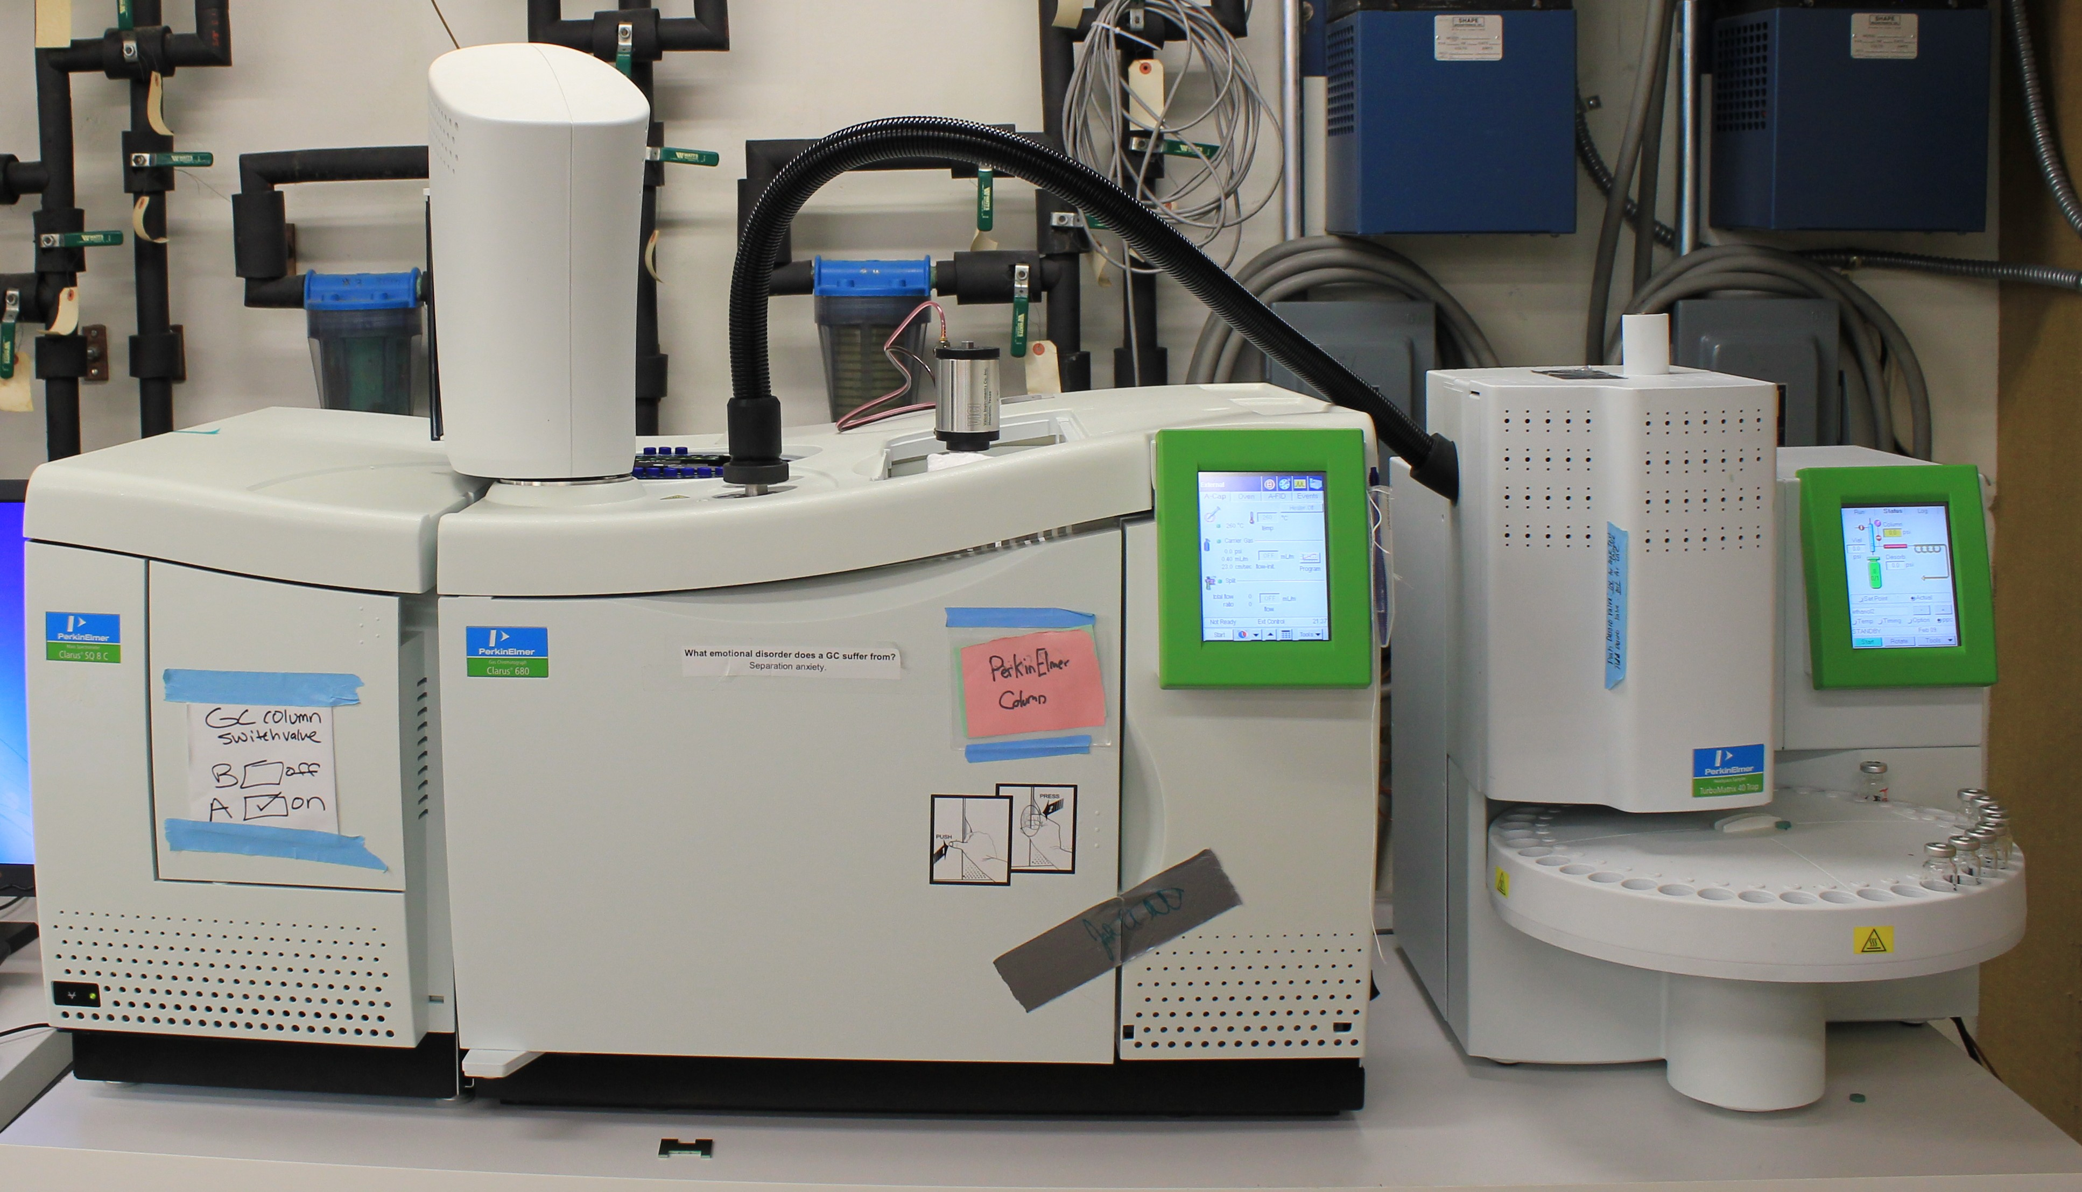

Ronald J. Gillespie (McMaster University).

Developed the Valence Shell Electron Pair Repulsion (VSEPR) theory to predict molecular geometry based on electron pair repulsion.

Education: Foundation of high school and university chemistry courses.

Industry: Guides drug design (molecular shape affects binding) and nanotechnology.

Society: Enables understanding of pollutant interactions and material properties.

Theory:

Electron pairs around a central atom arrange to minimize repulsion, determining shapes like linear, tetrahedral, or trigonal planar.

1. National Institute of Health. (2023). How MRI Works. [https://www.nih.gov/mri](https://www.nih.gov/mri" \t "https://chat.deepseek.com/a/chat/s/_blank)
2. McMaster University. (2020). Ronald J. Gillespie’s Legacy. [https://chemistry.mcmaster.ca/gillespie](https://chemistry.mcmaster.ca/gillespie" \t "https://chat.deepseek.com/a/chat/s/_blank)
3. Wikimedia Commons. (CC BY 4.0). VSEPR Molecular Shapes.
4. Canadian Nuclear Association (CANDU reactor details).
5. Royal Society of Chemistry (Infrared spectroscopy applications).